Serverless computing

1. Create s3 bucket
Upload an object(images of jpg and png format)

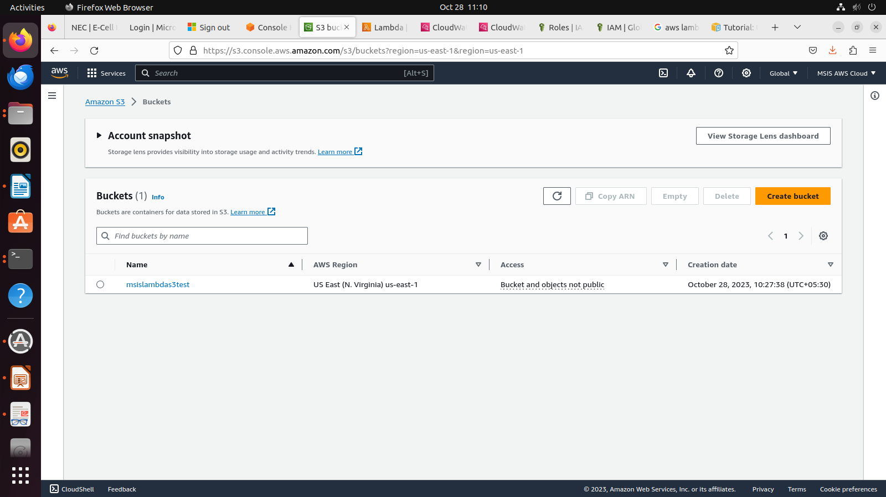
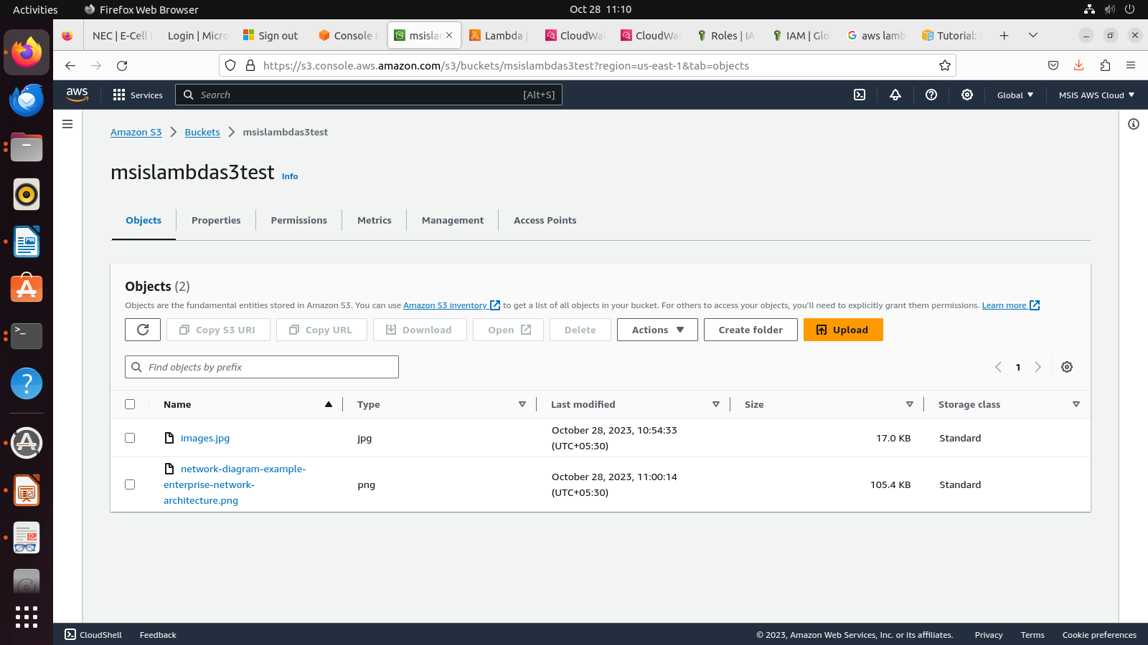

2. Create policy

Effect – Gives permission
Actoin - Specify get(read), put, post (write)

From the policy we create roles
By default,
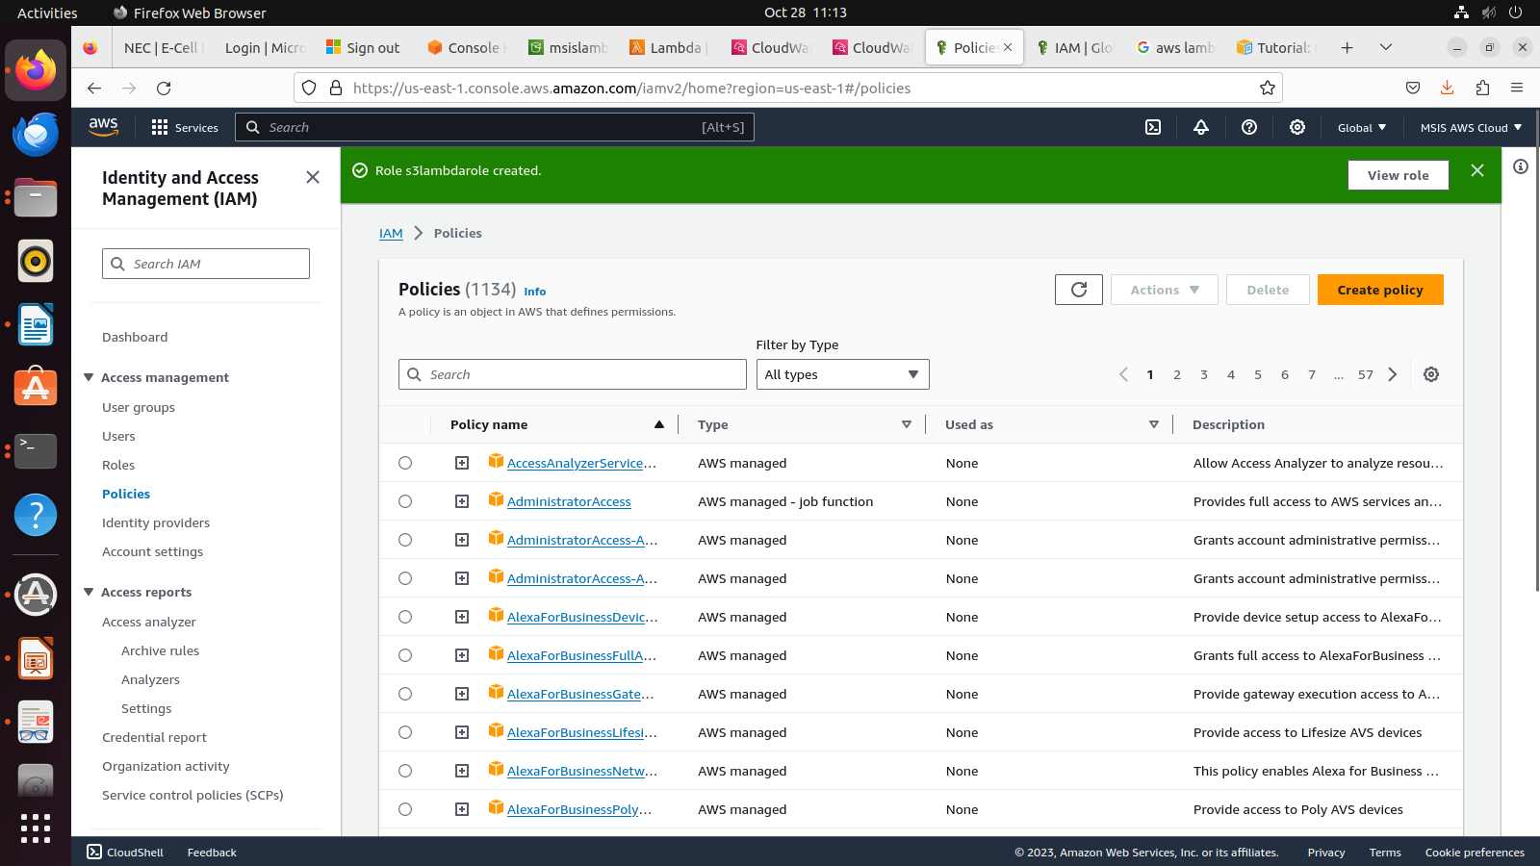
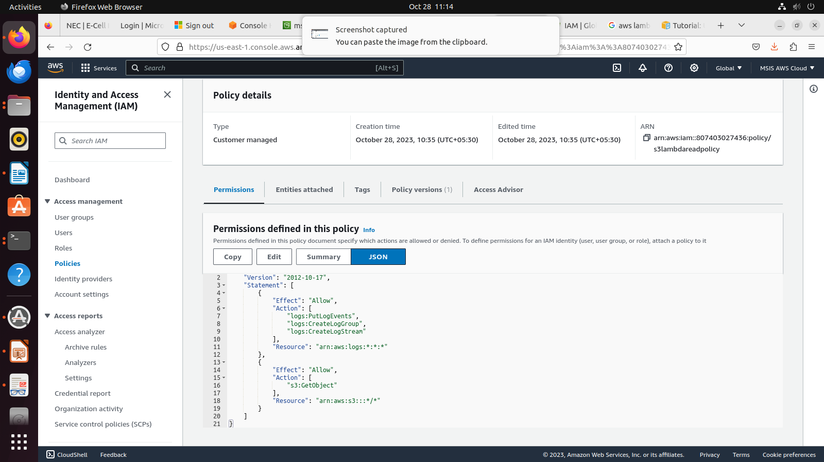
Policy
{
"Version": "2012-10-17",
"Statement": [
{
"Effect": "Allow",
"Action": [
"logs:PutLogEvents",
"logs:CreateLogGroup",
"logs:CreateLogStream"
],
"Resource": "arn:aws:logs:*:*:*"
},
{
"Effect": "Allow",
"Action": [
"s3:GetObject"
],
"Resource": "arn:aws:s3:::*/*"
}
]
}

3. Create role
Select lambda as a serve
Select created policy
Give a role name(name-s3lambdarole)
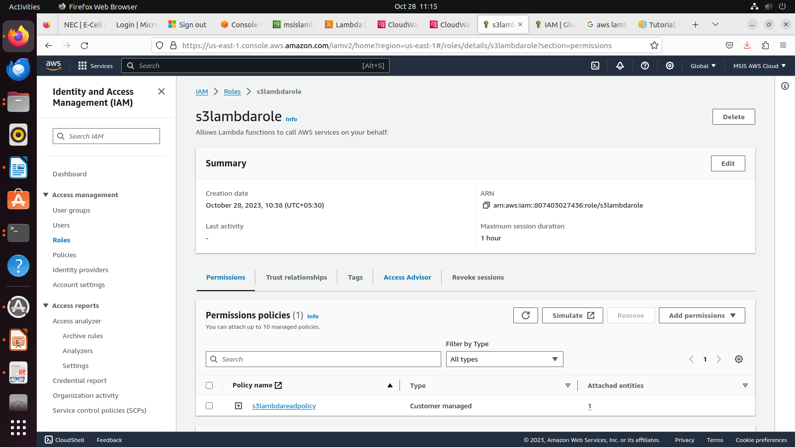
4. Create function
Create lambda – s3lambdatest
Choose a runtime environment
Python 3.9 (lambda Support Go, java, nodejs, ruby etc)
Choose architecture (either arm or x86_64)
Attach execution role
use an existing role(s3lambdarole)
Create function

Python code for trigger
import json
import urllib.parse
import boto3

print('Loading function')

s3 = boto3.client('s3')

def lambda_handler(event, context):
#print("Received event: " + json.dumps(event, indent=2))

# Get the object from the event and show its content type
bucket = event['Records'][0]['s3']['bucket']['name']
key = urllib.parse.unquote_plus(event['Records'][0]['s3']['object']['key'], encoding='utf-8')
try:
response = s3.get_object(Bucket=bucket, Key=key)
print("CONTENT TYPE: " + response['ContentType'])
return response['ContentType']
except Exception as e:
print(e)
print('Error getting object {} from bucket {}. Make sure they exist and your bucket is in the same region as this function.'.format(key, bucket))
raise e

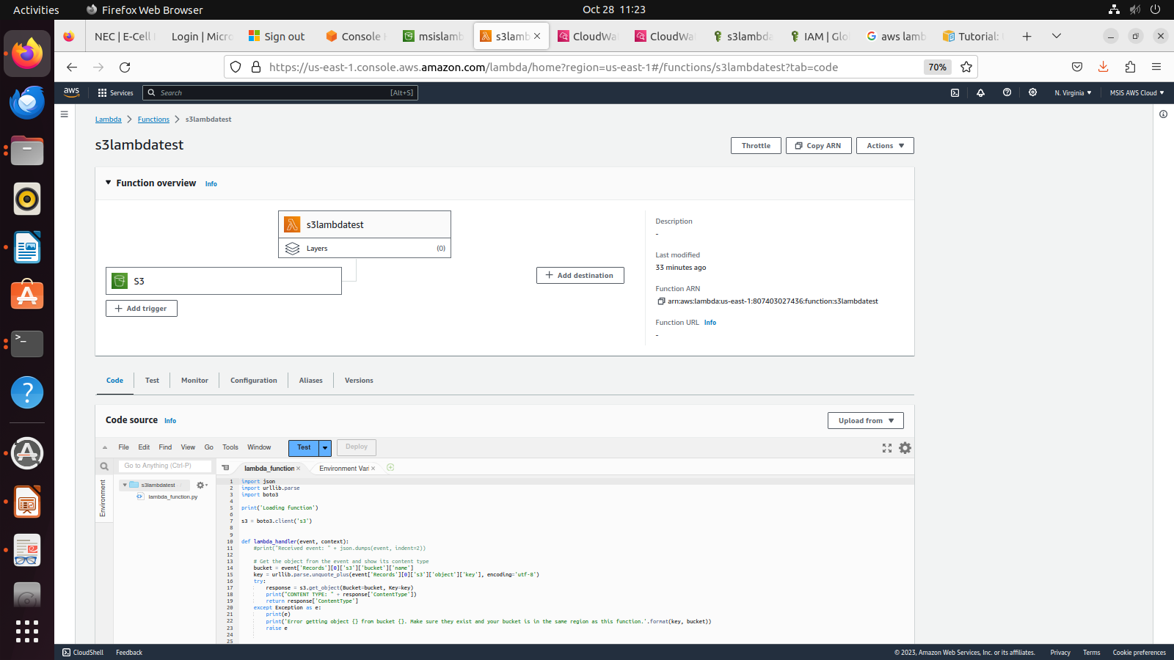
5. Add trigger
Test event – formatted json event
Specify region, name of bucket and object in the code

Code for testing
{
"Records": [
{
"eventVersion": "2.0",
"eventSource": "aws:s3",
"awsRegion": "us-east-1",
"eventTime": "1970-01-01T00:00:00.000Z",
"eventName": "ObjectCreated:Put",
"userIdentity": {
"principalId": "EXAMPLE"
},
"requestParameters": {
"sourceIPAddress": "127.0.0.1"
},
"responseElements": {
"x-amz-request-id": "EXAMPLE123456789",
"x-amz-id-2": "EXAMPLE123/5678abcdefghijklambdaisawesome/mnopqrstuvwxyzABCDEFGH"
},
"s3": {
"s3SchemaVersion": "1.0",
"configurationId": "testConfigRule",
"bucket": {
"name": "msislambdas3test",
"ownerIdentity": {
"principalId": "EXAMPLE"
},
"arn": "arn:aws:s3:::msislambdas3test"
},
"object": {
"key": "images.jpg",
"size": 1024,
"eTag": "0123456789abcdef0123456789abcdef",
"sequencer": "0A1B2C3D4E5F678901"
}
}
}
]
}

Click on save and test
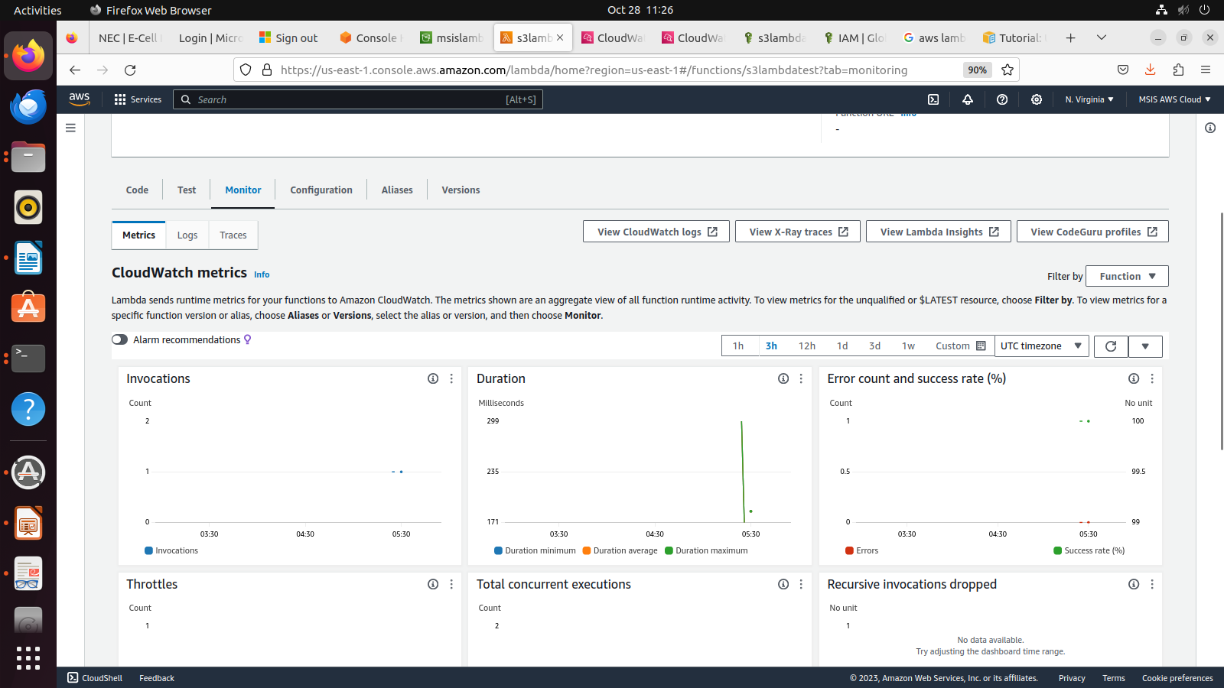
You can see the log on clicking view cloudwatch logs
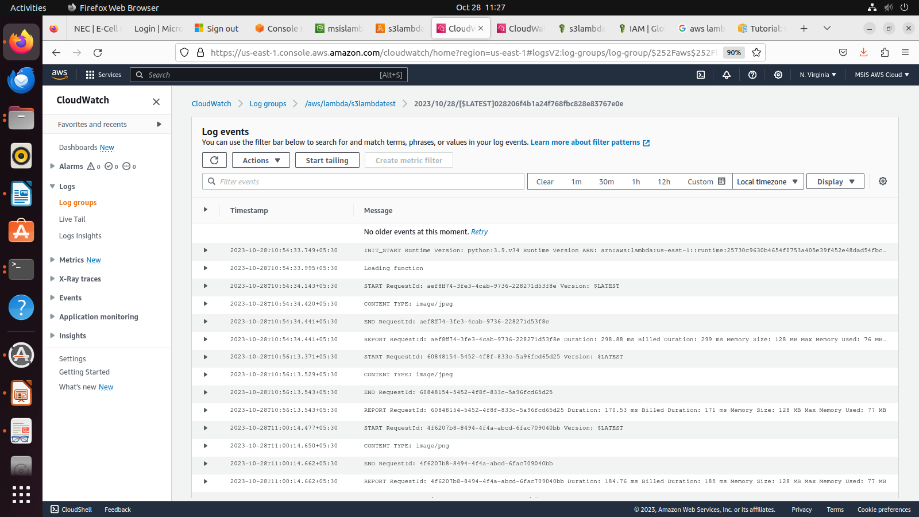
observe content : images/jpeg and images/png

